I. SIR SYED PANDEMIC CARE PACKAGE
Objectives:
- To help the society in general and students in particular to overcome he challenges and crises of the pandemic.
- To ease the transition ofthe students, parents and teachers from the traditional formal classroom to the new online class.
Context:
The challenges and treats posed by the Covid-19 pandemic were unprecedented and the general public and the stakeholders found themselves in a lurch.
Sir Syed College rose to the occasion and launched a series of programmes to help mitigate the psychological, economical and educational crises faced by the students, their parents and the immediate society.
CARE PACKAGE
1. EXIGO
An online three day orientation programme offered to the plus two passed students and their parents about the UG programmes offered by Kannur University. the programme was inaugurated by Dr. Vincent P J, Controller of Examinations , Kannur University. Key Note address was delivered by Shahid Thiruvallur, IAS and sessions were lead by Mr. Zakariya M V. The programme was attended by more than 500 participants who were from Kannur, Kasargod and Wayanad districts.
The apprehensions of the parents and students were cleared and career prospects of each and every UG programme and scope for further studies were explained over the three days' sessions.
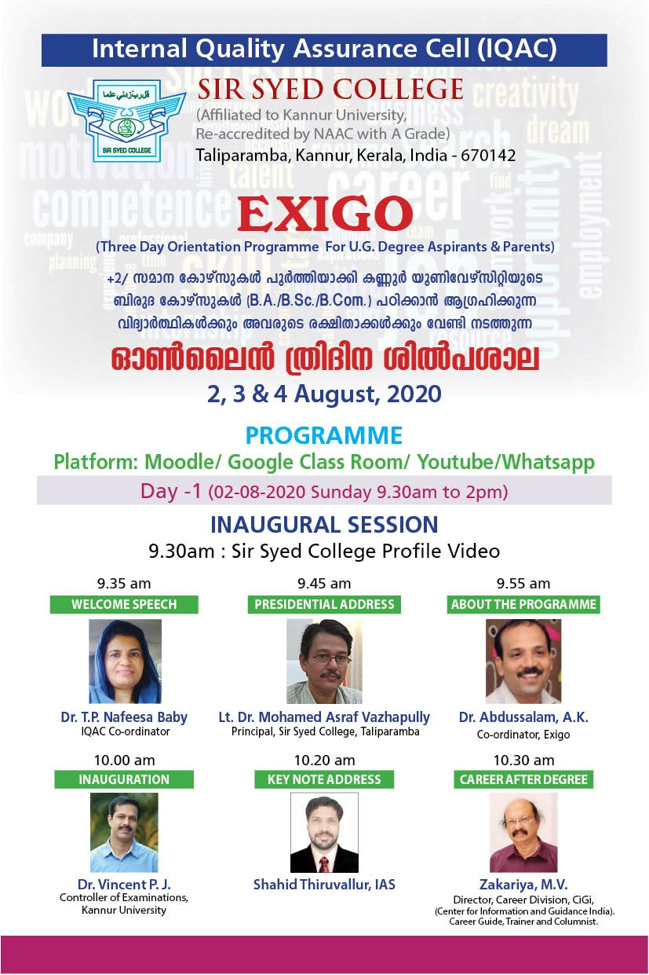
2. m-Power Santwana Sparsham
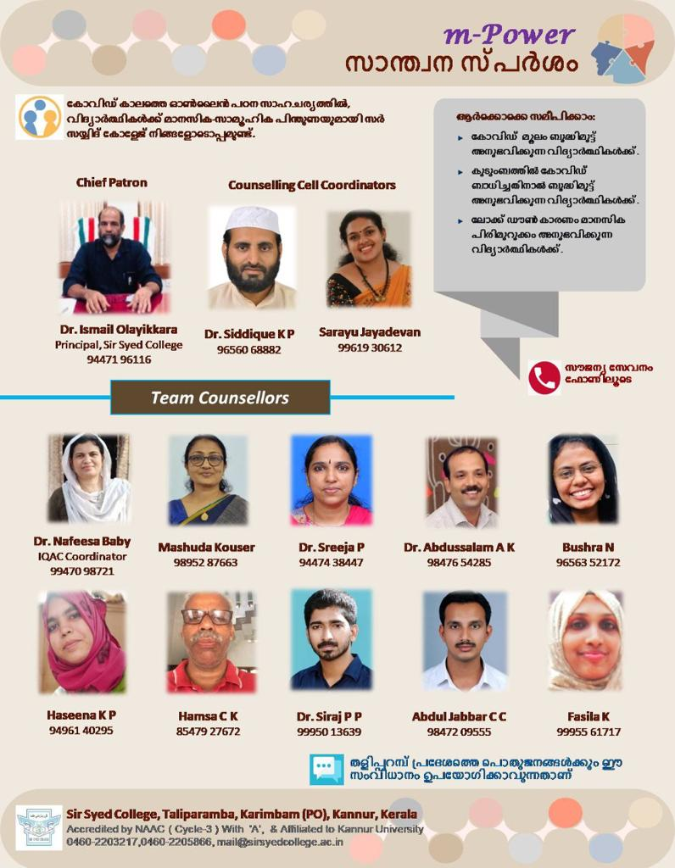
It’s a programme organized to provide psychological counselling to the public in general and students in particular to alleviate the stress and depression caused by lock down. The programme could provide relief to143 people from different walks of life.
3. Mask and Sanitizer Making and Distribution
Masks and sanitizers were made in large quantities during the initial phase of Covid-19 on the campus and distributed among the public free of cost. The programme was lauded by the entire community as there were acute shortages of masks and sanitizer then.
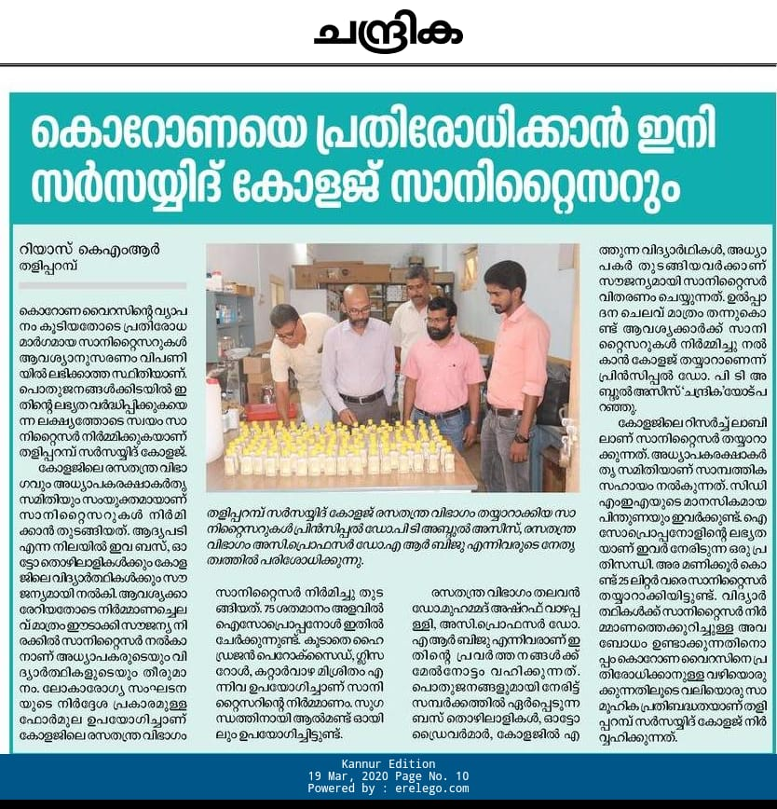
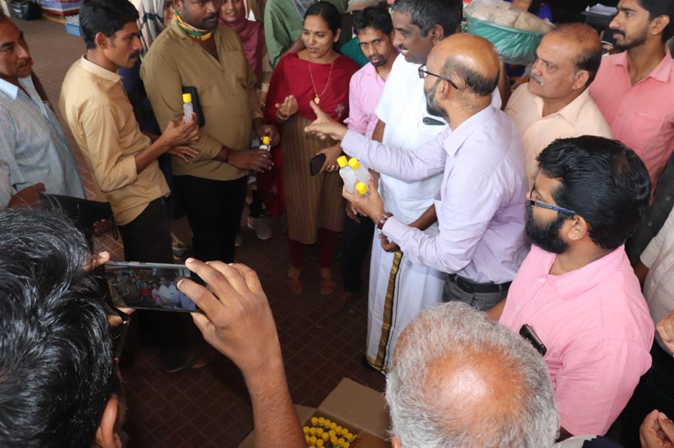
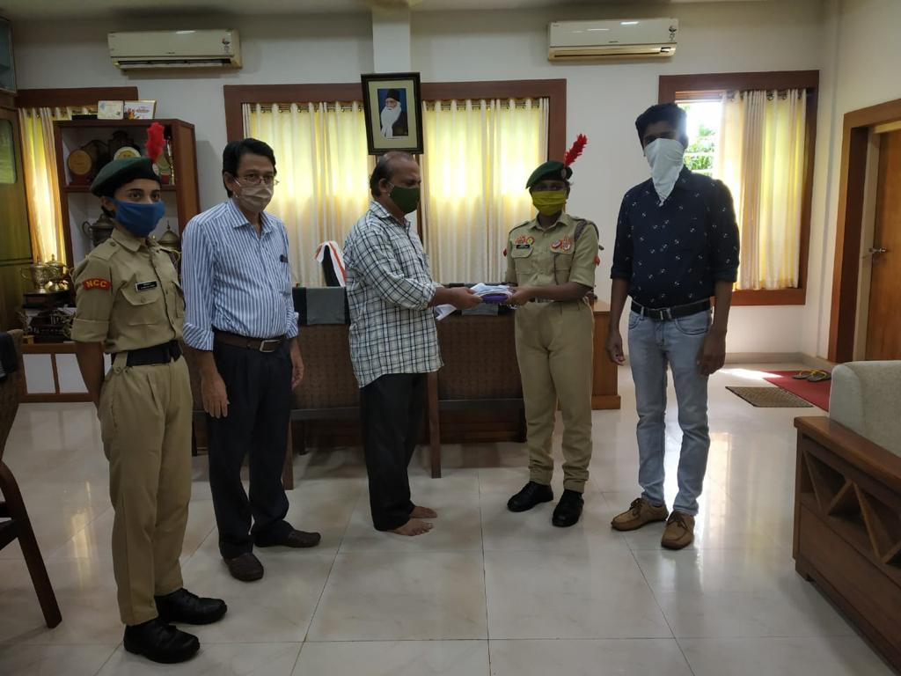

4. MOODLE
Sir Syed College was one of the first colleges under Kannur University to implement a full-fledged Learning Management System, MOODLE for the conduct of online classes.
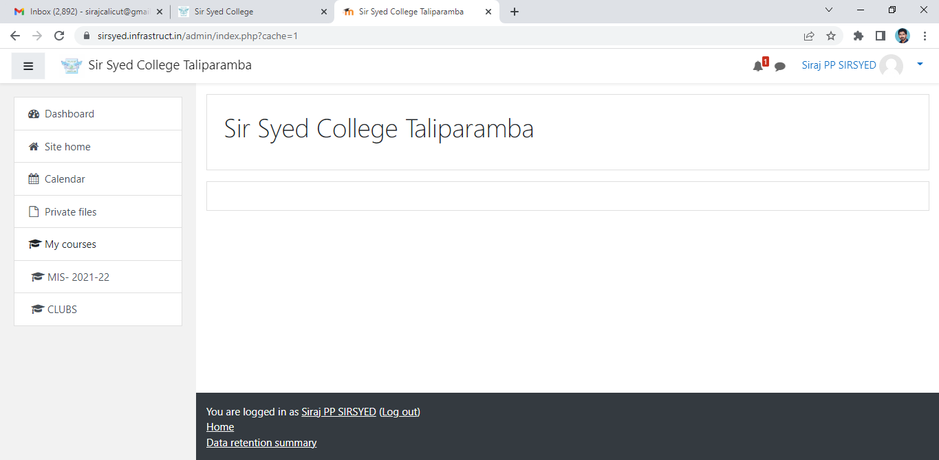
5. Food Kit Distribution
Food kits were sourced from teachers and alumni and distributed in the colonies of scheduled tribes during lock down.
Shramdaan and donations were made by the Staff Association to the community kitchen run by the government during lock down.
Vegetable kits were distributed on the eve of Vishu ( a popular festival of Kerala) free of cost to the needy in the locality so as to ensure that they don't miss out on the festival.
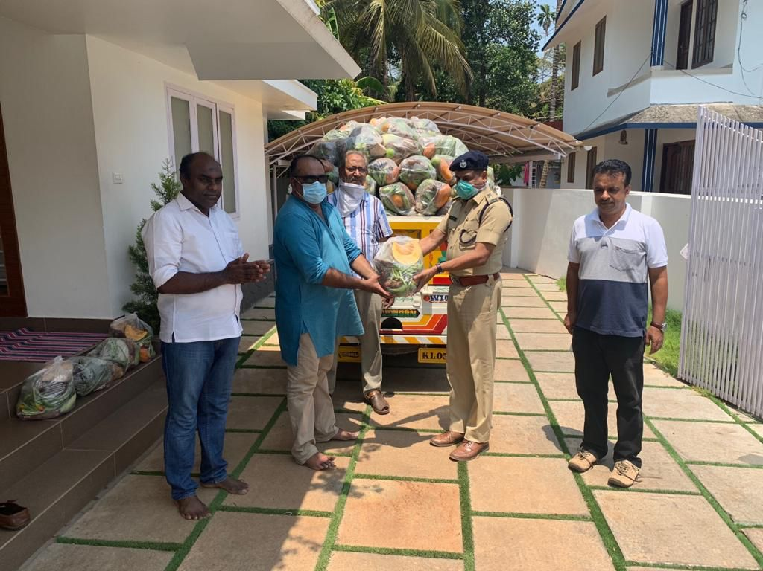
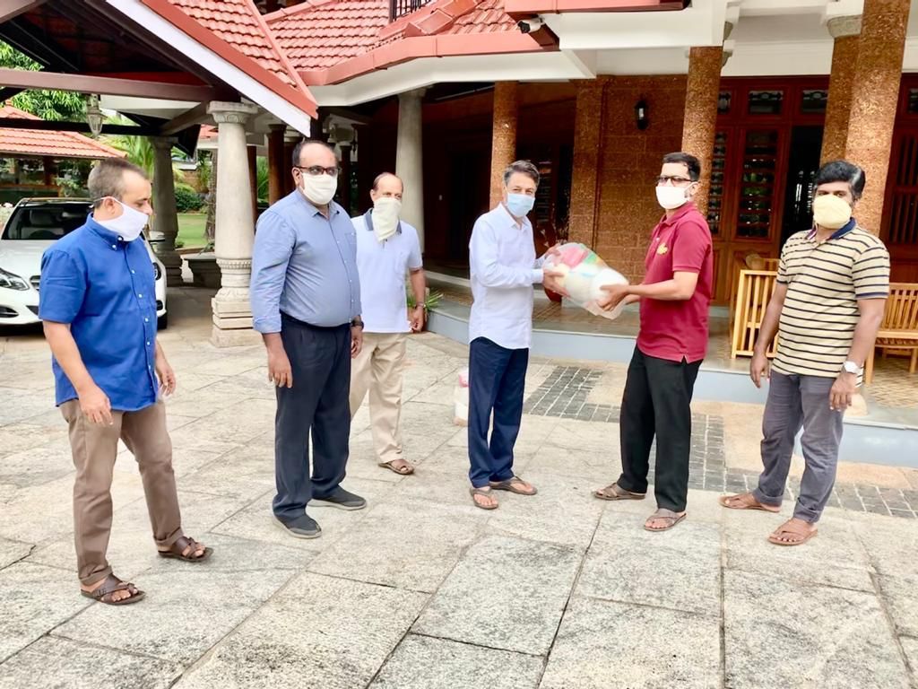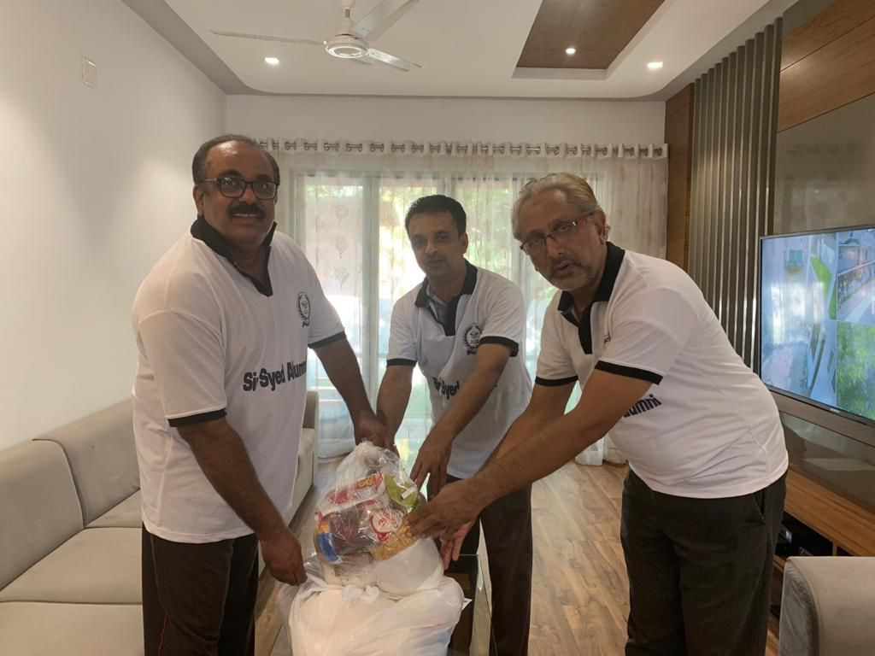
6. Sunglass Donation to the Police
UV Sunglasses were donated to the police to help them in their patrolling duties during lock down.
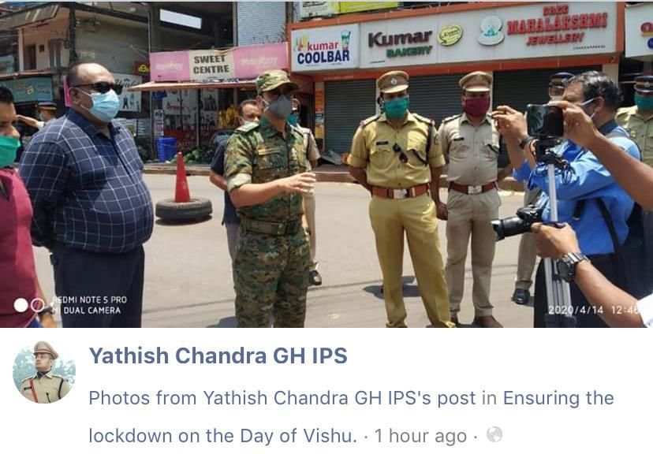
7. Mobile Phone Distribution
Mobile phones were distributed to economically challenged students of the college by PTA, Alumni and Staff Association so as to ensure their inclusivity in the teaching learning process.
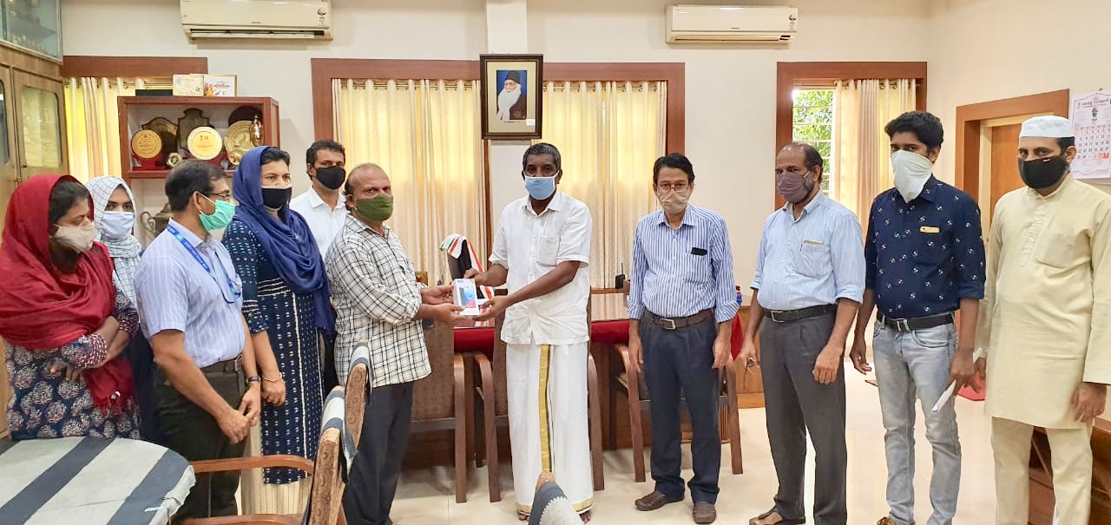

II. NET COACHING
Objectives
- To help students maximise their skillsets.
- To provide a more emphatic and participative approach to their respective subjects.
- To help students advance their career options.
Context
There is no NET- JRF training centers in the subdistrict of Taliparamba. The nearest quality training centres are at Calicut which is 100 km away. Hence, accessibility was a huge problem for the students of the college and other NET - JRF aspirants.
NET- JRF Training:
Training is provided for Paper I and Paper II for Commerce, English, Arabic and Physics. During the year 20-21, training was provided on online mode due to the pandemic .Two batches ( June batch & December batch) were run. Classes were conducted on Saturdays and Sundays. A total of 270 students (June & December batch together) enrolled out of which 11 students secured NET when the result of June batch was declared. result of the December batch is awaited.
Apart from these, a three day online crash course for paper I (General Paper) was also conducted free of cost.

